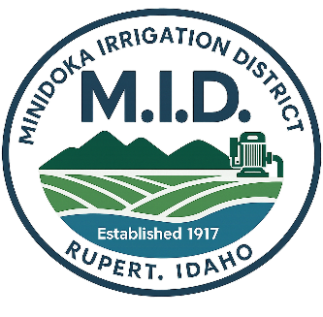
MINIDOKA IRRIGTION DISTRICT
98 WEST 50 SOUTH
RUPERT, ID 83350
(208)436-3188
www.minidokairrigationdistrict.org
Equal Employment Opportunity Provider & Employer

Job Description: GIS Specialist
Position Summary:
The GIS Specialist is responsible for the development, maintenance, and expansion of the Minidoka Irrigation District's Geographic Information System (GIS) and associated databases. This position collects, manages, analyzes, and presents spatial data related to the District's canals, laterals, drains, structures, rights-of-way, land ownership, water delivery systems, and other District assets.
The GIS Specialist provides mapping, reporting, and technical support to District management and staff, assists with the District's water delivery monitoring systems, and serves as backup support for customer service and office operations.

Essential Duties and Responsibilities
- Maintain and expand the District's GIS database and mapping systems.
- Collect, edit, verify, and manage spatial and attribute data using GIS software and field data collection methods.
- Create maps, exhibits, reports, and analyses for District staff, management, and Board use.
- Maintain accurate records of District infrastructure, including canals, laterals, drains, structures, easements, rights-of-way, and service areas.
- Perform field verification and data collection as needed.
- Assist customers, landowners, contractors, and consultants by providing maps and GIS-related information.
- Maintain GIS records associated with ownership changes, subdivisions, easements, and District facilities.
- Assist with accounts receivable functions as assigned.
- Provide customer service and backup support for office operations.
- Perform other duties as assigned.

Minimum Qualifications
- Associate degree, technical certificate, or equivalent combination of education, training, and experience in Geographic Information Systems (GIS), Geography, Computer Science, Information Technology, or 2 years’ experience.
- Demonstrated proficiency with ESRI suite of software: ArcGIS Pro, Field Maps, Survey123, Cadastral Mapping, Remote Sensing (GNSS remote sensing), COGO editing, Python for GIS, Arcade Expressions.
- Working knowledge of coordinate systems, map projections, datums, georeferencing, and spatial data management.
- Proficiency with Microsoft Office applications and general computer systems.
- Ability to learn and use District software and technology systems.
- Strong analytical, organizational, and problem-solving skills.
- Ability to communicate effectively with the public and District staff.
- Ability to work independently and as part of a team.
- Valid driver's license with an acceptable driving record.

Preferred Qualifications
- Bachelor's degree in GIS, Geography, Computer Science, Information Technology, or a related field.
- Experience working with irrigation districts, agriculture, utilities, public works, or water resources.
- Experience with GPS/GNSS data collection and mapping.
- Experience with database management and data analysis.
- Customer service and office administration experience.

Working Conditions
Work is performed in both office and field environments. Occasional field work may require walking uneven terrain, ability to lift 25lbs, working near water conveyance facilities, and exposure to varying weather conditions.

